Date: 6/19/2018
Subject: Action Required: In-Ground Manual Traffic Spikes; Bearing Hardware
Products Affected: 11300 Series, 11600 Series, Traffic Spikes

LiftMaster has received a limited number of customer reports that the Bolts and Nuts that hold the pillow block bearings in place would come loose easily, or prematurely. This applies to 11300 and 11600 series product that was shipped between January 1, 2018 and June 7, 2018.

The assembly of these units utilized a stainless steel nut on a 3/8” diameter stainless steel bolt. If this hardware becomes loose it can result in the misalignment of the mechanism, binding, and/or damage to the bearing.
Checking the system for proper operation, removing debris, and checking the condition of the mechanism is part of routine maintenance for a traffic system.

Action Required: In order to better assure that the hardware holding the bearings remain properly secured, LiftMaster is providing a Hardware Replacement Kit to be installed to all potentially affected spike systems. This kit provides replacement hardware for one 3ft. spike section. Following items are included in the update kit:
- Quantity 4, 3/8-16 x 1-3/4” BOLT, 18-8 ST STEEL
- Quantity 4, 3/8 x 1/8” THK WASHER, 18-8 ST STEEL
- Quantity 4, 3/8-16 NUT, FLANGE, NYLOCK, 18-8 ST STEEL
- Quantity 1, 263 LOCTITE
To receive an update kit, call our technical support center at 1-800-528-2806.
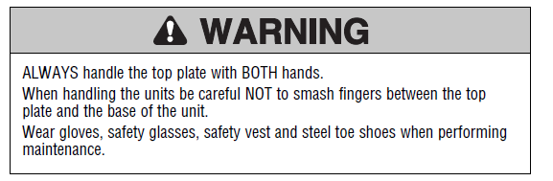
TOOLS REQUIRED
• 7/16" socket or wrench for the latch-down device
• 9/16" socket or wrench for the top plate and bearings

Hardware Replacement procedure:
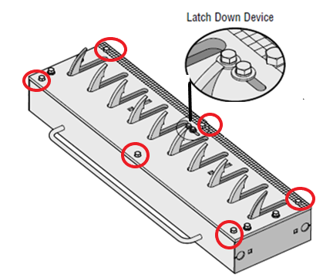
- Use the 7/16” socket or wrench to unlatch the lock down device, press the teeth down and slide the latch down device in front of the teeth to hold them down. Retighten the bolt.
- Use the 9/16” socket or wrench to loosen ONLY the six mounting bolts that secure the top plate to bottom assembly, and lift the top plate assembly from the spike system.
- Locate the two bolts holding each of the pillow-block bearings in place, and the existing hardware.
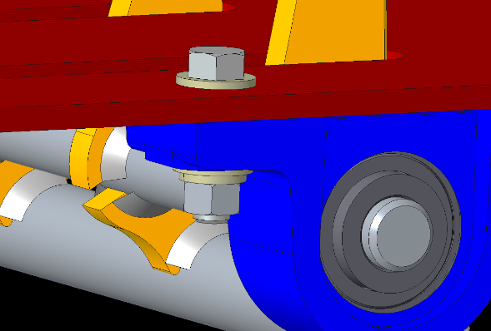
Item 1) 3/8-16 X 1” BOLT - DISCARD
Item 2) 3/8 X 5/64” KEEP ONE WASHER
Item 3) 3/8 SPLIT WASHER Discard
Item 4) 3/8-16 HEX NUT Discard

- Replace only one bearing bolt at a time, do not loosen the other ones. Loosening all the bolts at once will result in misalignment of the spikes.
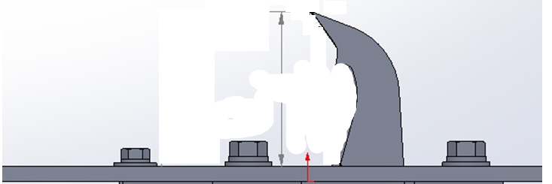
- Examine the hardware and the position of the Pillow-Block Bearing. NOTE: If the bearing appears to be loose it will be important to check the alignment of the bearing. Once the procedure is complete, the height of the spikes should be as follows:
Spike Height Measurement:
- 2 ½ inches on Standard Duty Models
- 2 5/8 inches on Heavy Duty Models

- Remove the nut, bolt, flat washers, split washer and discard them all, with the exception of one flat washer (item 2).
- Apply an abundant amount of 263 Loctite to the threads of the new bolt.
- Insert the bolt, placing one of the original removed flat washers (item 2 from the drawing above) under the bolt head.
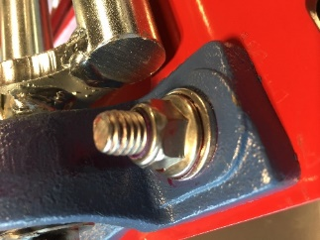
- Insert new, thicker flat washer on the bearing side of the bolt.
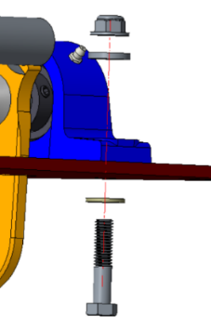
- Insert new flanged nut and tighten very securely. If you have a torque wrench, this should be set to 35 ft-lbs.
- Reassemble the top plate to the spike system. IMPORTANT NOTE: Do not apply loctite to the bolts that secure the top plate. These bolts must remain removable for routine maintenance of the system.
- Use the 7/16” socket or wrench to unlatch the lock down device, and slide it out of the way of the teeth. Retighten the bolt.
- Check the teeth assembly to ensure proper movement.
The Loctite may take 36-48 hours to cure. Please keep the Spikes in the locked-down position for this period of time to facilitate this curing process.

If you have any questions regarding the information above, please do not hesitate to contact our technical support center at 1-800-528-2806

